- Setup WSL and Docker
- Do the mandatory software installation (NVM, Node, etc.,)
- Open the Run command and ‘%USERPROFILE%’ command and create one new file ‘.gitconfig’
- Open PowerShell and Run the command “git config --global --list” and ensure following values are returned
  - http.sslbackend=schannel (This line responsible to make sure SSL certificate will be considered from trusted root authorities of windows)
  - credential.helper=wincred (This line to maintain Git credential in windows credential manager)
- If any one of the config is not available add manually using below command
  - git config --global http.sslBackend schannel
  - git config --global credential.helper wincred
- you can remove the git global config using below command
  - git config --global --unset http.sslBackend
  - git config --global --unset credential.helper
- Run the command “git config --system --list” and ensure there is no ‘credential.helper’ entry, if the command gives error message it’s okay to proceed, if entry found kindly remove using command ‘git config --system --unset credential.helper’ since this entry gets conflicted with global setting
- Clone the IKEA Repo, Repo URL: https://github.com/Inter-IKEA-Digital/CMF-MES-industry-cmf-mes-customization into new folder
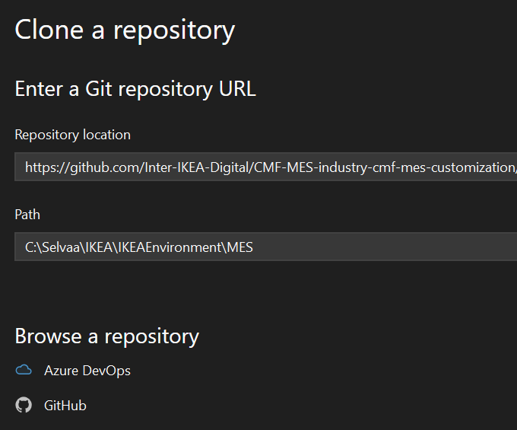
- Enter IKEA Sign-In credential if asked
- Authorize the GitHub
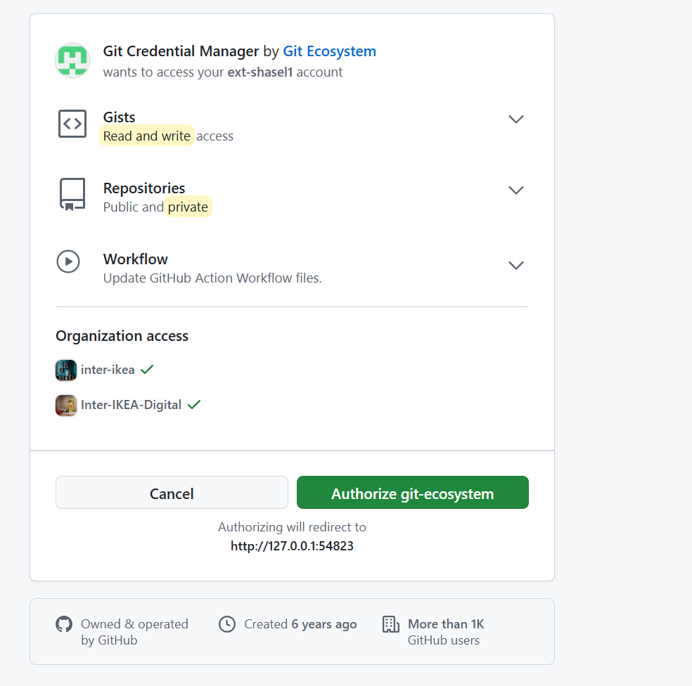
- Connect Cisco AnyConnect VPN
- Open this network path in windows file explorer \\PLMDC-NT4002
Connect with your IKEA email, ext_xxxxxx@swedwoodgroup.com
- Open new Terminal window and navigate to <REPO URL>\Tools and execute ‘.\Local_GetLocalEnvironment.ps1’ command
- Following error might receive during GetLocalEnvironment command execution, kindly ignore
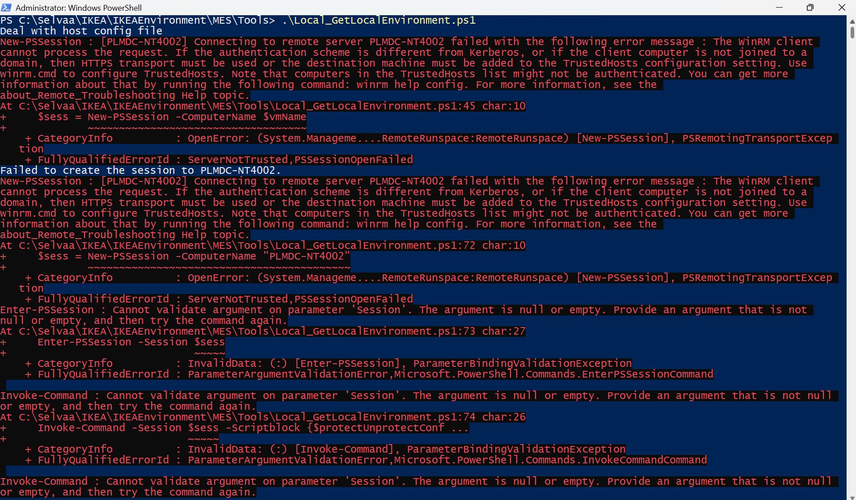
- Script will start to copy local Environment to local from Server & Wait for completion.
